A Java PriorityQueue stores elements according to priority, not insertion order. Internally, Java implements it using a binary heap.
By default, Java’s PriorityQueue is a min-heap, meaning the smallest element has the highest priority.
import java.util.PriorityQueue;
public class PriorityQueueExample {
public static void main(String[] args) {
PriorityQueue<Integer> queue = new PriorityQueue<>();

queue.offer(30);
queue.offer(10);
queue.offer(20);
queue.offer(5);
System.out.println(queue.peek()); // 5
while (!queue.isEmpty()) {
System.out.println(queue.poll());
}
}
}

queue.offer(value); // Add an element
queue.peek(); // View highest-priority element – in min heap scenario smallest element
queue.poll(); // Remove highest-priority element

Min-heap
Java creates a min-heap by default:
PriorityQueue<Integer> minHeap = new PriorityQueue<>();

minHeap.offer(30);
minHeap.offer(10);
minHeap.offer(20);

System.out.println(minHeap.peek()); // 10
The smallest number is removed first.

Max-heap
To remove the largest number first, supply a reverse comparator:
import java.util.Comparator;
import java.util.PriorityQueue;

PriorityQueue<Integer> maxHeap =
new PriorityQueue<>(Comparator.reverseOrder());

maxHeap.offer(30);
maxHeap.offer(10);
maxHeap.offer(20);

System.out.println(maxHeap.peek()); // 30

while (!maxHeap.isEmpty()) {
System.out.println(maxHeap.poll());
}

Heap:
What if the smallest element always sit at first in the array, no sorting needed that is called heap. Heap is just an array where smallest element always sit at index 0, if we remove smallest element then next smallest will come to index 0. Eventhough it is a flat array, it is easy to understand if we represent it as binary tree.
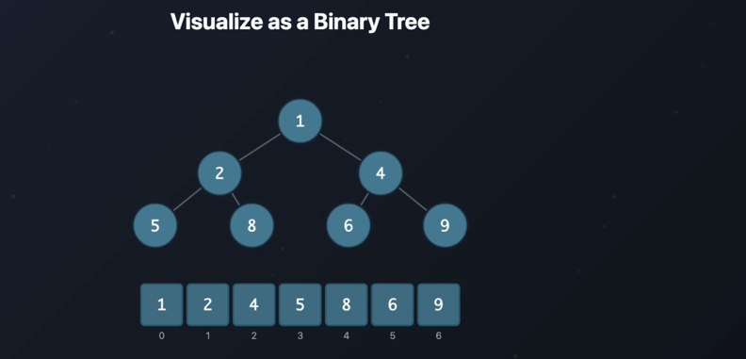
Given array is valid heap, how it is represented in the tree is, first node is the root, then next 2 nodes will come in next layer. Values will be filled layer by layer. One thing to note here is every parent is smaller than both of its child node. This is called MIN-HEAP.
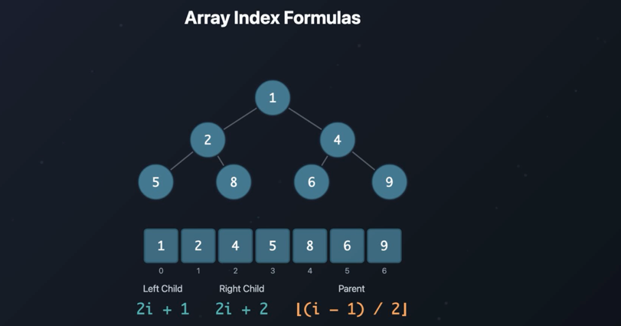
Array index formula
Left child - 2i + 1
Right child – 2i + 2
Parent – Lower(i-1)/2
Here i is the index of the element
To find left and right child of 2
Element 2 is at index 1
Left = 2i + 1
= 2*1 + 1
= 3 element which is in 3rd index is the left child of node 2
Right = 2i + 2
= 4 element which is in 4th index is the right child of node 2
To find parent node of 6
Element 6 is at index 5
Parent = lower((i-2)/2)
= l((5-2)/2)
= 2 element which is in 2nd index is 4 which is the parent of 6
Heaps are complete binary trees, every level is fully filled except last level.
MAX heap: every parent is greater than or equal to its children
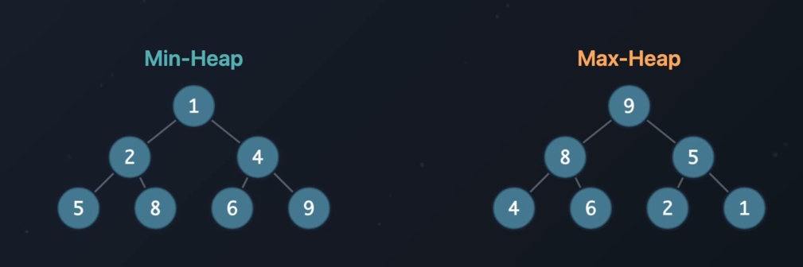
Heaps overpowers priority queues. It can be used for priority queues (grab the most important item), shortes path (Dijkstras algorithm), Merge k list(smallest head at each step), Running median (two heaps one answer)
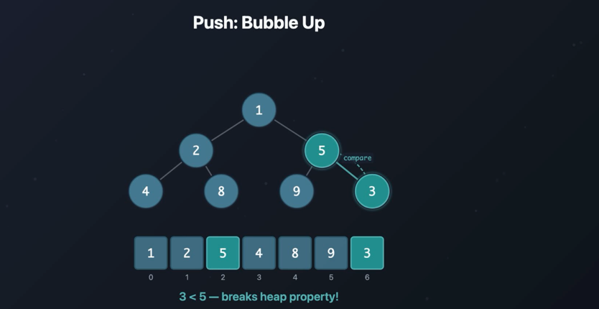
There are 2 operations in the heap, push and pop. While doing push number is added at last in the array, then it will compare it with its parent, in above case we are adding 3 and its parent is 5 and it is a min heap so parent should be smaller than its children and it is breaking that rule so swap it, now new parent is 3 and its children are 9 and 5 this matches with min heap property. 3’s parent is 1 which is already smaller than 3 so heap property is fine. This process is called bubble up – the new elements swaps upward until it finds the correct spot.
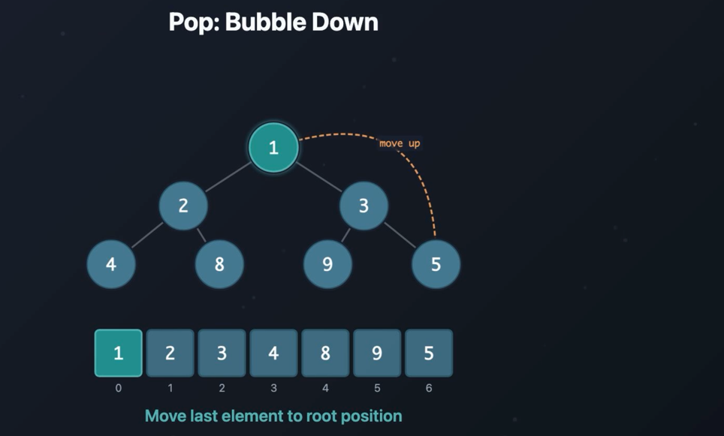
In heap pop is always root element, while popping root, last element in above case 5 is moved up to root. Now 5 is bigger than both of its child, so it gets swapped with SMALLER element
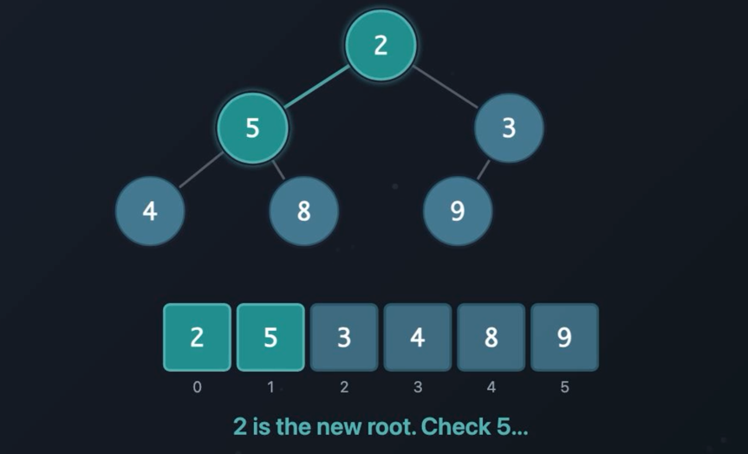
Now 5 is bigger than one of its child so it gets swapped with smaller one, this process is called Bubble down.
Heapify: Build a heap in O(n)
Take random array and turn it into valid heap (in place without exta memory)
- Start from last node which has children
- Works backwards towards the root
- Bubble down each node into position
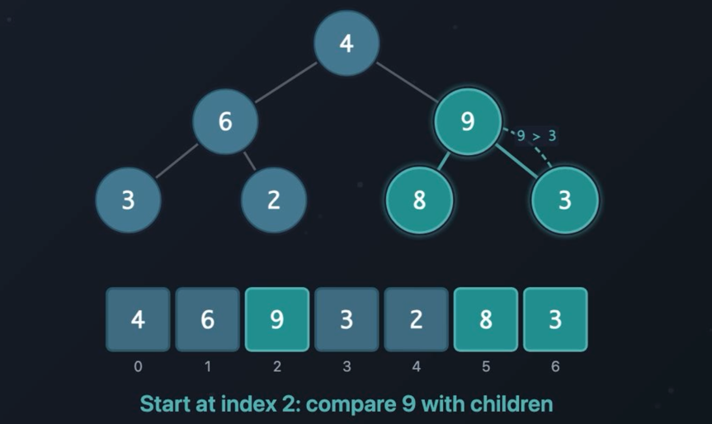
Starts with right side last node which has children, if parent is greater than both of its children then swap it with smaller, then move to left side node and repeat same process.
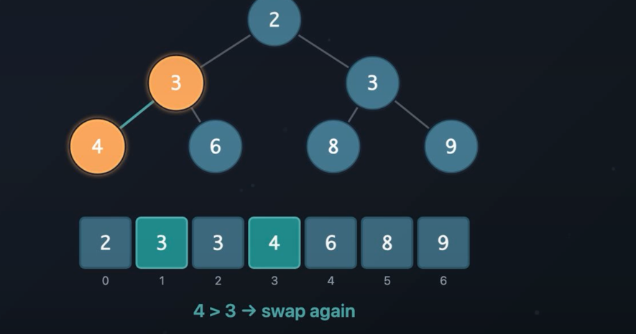
The top K pattern:
Given an array find the K largest elements. Brute force is sort the array and get last K elements. This is O(n log n), we can accomplish this with O(n log k) using min heap.
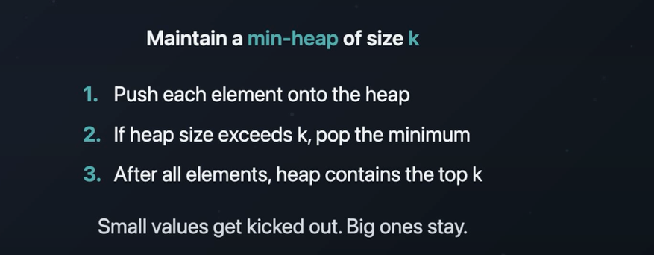
Why min heap – in min heap root element will be smaller and we need largest K so using min heap is the correct solution, if we need smallest K then we need to use max heap.

